National University of Computer and Emerging Sciences



Laboratory Manuals

for

Web Programming
(CS4032)

Course Instructor | Mr. Muhammad Kamran
Section | BCS-6A/BCS-6B
Semester | Spring 2026

Department of Computer Science
FAST-NU, Lahore, Pakistan
- Design UI component where you upload the timetable
  - Parse the timetable i.e. course, time, venue etc
  - Show the timetable
  - Upload Clash Report
  - Filter Timetable and show clashing courses
  - Display the count of clashing students in each slot and in front of each course individually
After Parsing Expected UI:
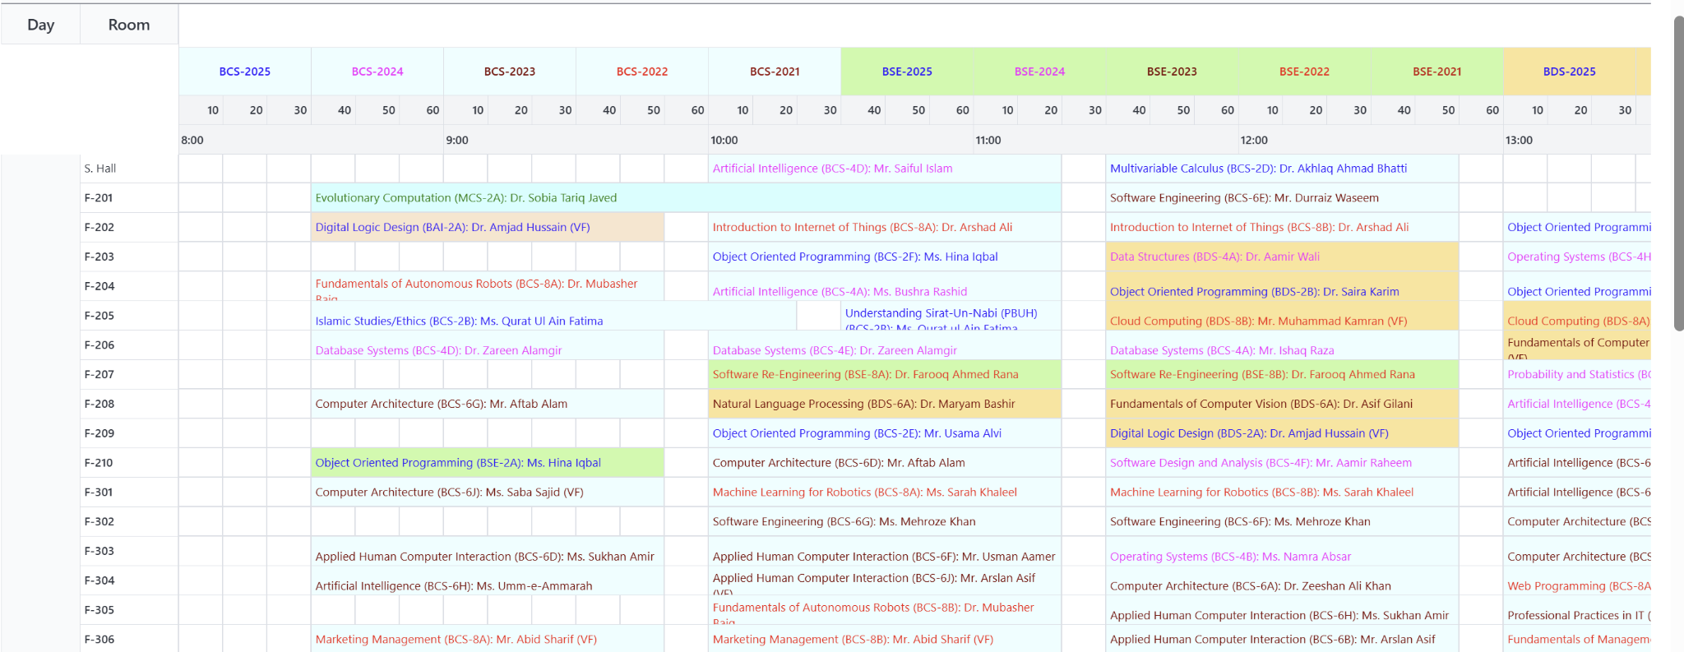
After Clash Report Upload expected UI:
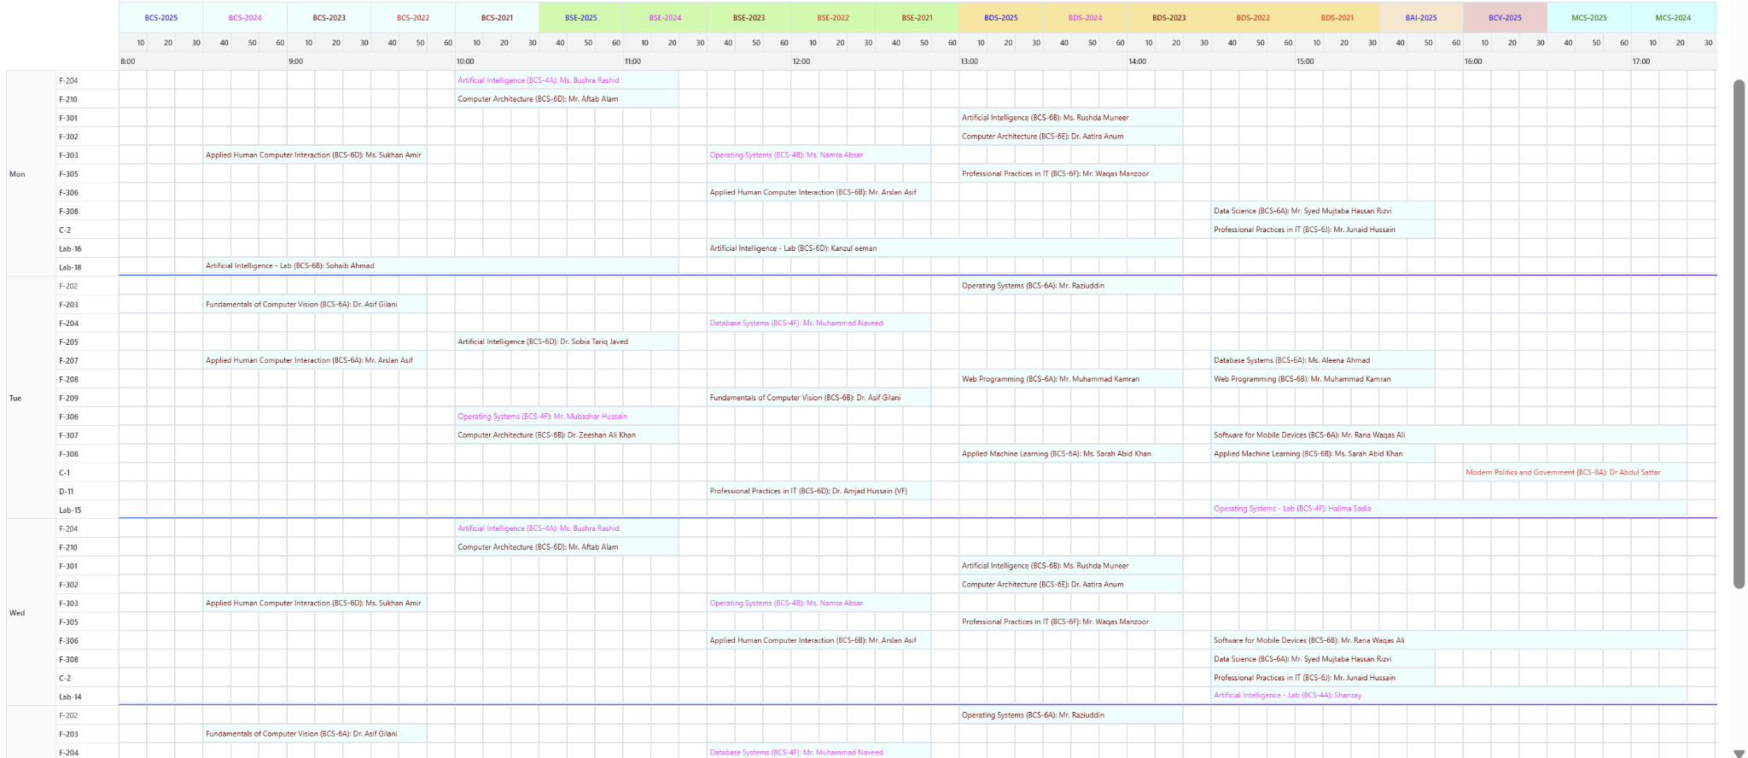
Live Testing link: https://fastops.vercel.app/timetable
Or something like:
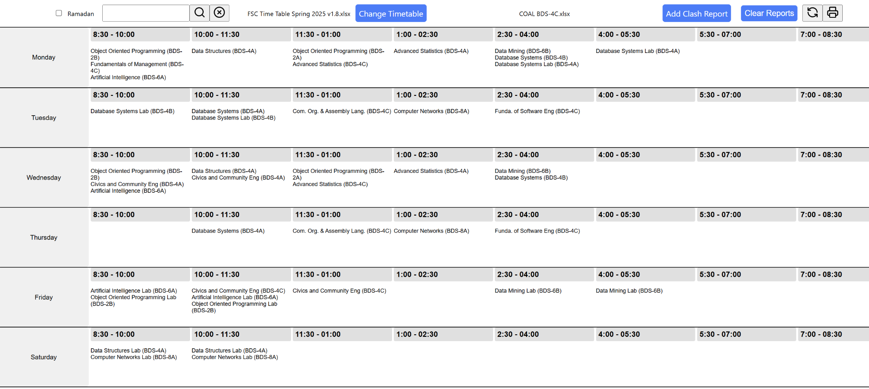

You can enhance UI/UX as per your wish but please ensure to practice following concepts:
- useState
- useEffect
- useContext
- useRef
- useMemo
- useCallback
- Implement some custom hook
—----------------------------------------------------------------------------------------------------------------------------------------

Submission Guidelines
- submit following the only file strictly following the naming convention
  - L241234.zip having src files not “node modules”

